Welcome to The Phoenix Theatre Company’s
Summer Camp and Master Classes 2019

Dear Parents/Guardians,
For those of you who are new to us, welcome! We have a wonderful summer ahead and we’re thrilled to have you joining us. To our returning families, you may notice some differences around the campus this year. For instance, we have a brand new name! We are now The Phoenix Theatre Company. We are a producing company, meaning everything you see on stage is made right here on our campus with artists from Arizona. Adding the word “company” to our name is a proud reflection of the people who help make us great. While we haven’t moved physical locations, you may notice a different address. This change was made to assist our families and guests find us easier.

Over the tenure of our summer camp classes, The Phoenix Theatre Company has continued to develop new and exciting theatre experiences for your campers and you can trust this year is going to be even bigger and better! Your camper will receive age-appropriate activities supporting his/her development as an individual and an artist. Our camps will be creative, challenging, and lots of fun! Please read this information carefully with your camper. We want to make sure everyone starts camp with all questions answered and expectations met in order to create the best experience possible.

Campers participating in our weekly musical theatre classes will be sharing their hard work with parents and friends on the Friday of each week of camp during the entire summer. *If you have signed up a camper for the 13-17 weekly courses, they will perform the only the second Friday of their chosen session. These sharing performances are FREE to attend and the children love having an audience! Feel free to invite family and friends. We open the building for the performance 15 minutes prior to show time and no earlier. Please consider how warm that summer sun can be in Phoenix and plan accordingly! For the safety of our campers, we cannot permit visitors in our building prior to that time. Thank you in advance for your understanding!

We are here to make sure your campers have a fun and educational camp experience! If you have any questions or concerns, please contact our team!

For registration prior to June 3, daily camp questions or concerns-
Hanna Spence-Schehr
Summer Camp Director
H.Spence-Schehr@phoenixtheatre.com
602.889.7608

Following June 3 you can reach our Camp Coordinator and the Assistant Camp Director at the same phone number.

Summer Camp Orientation:
Weekly Class Orientation: Saturday May 18th, 2019 from 9:00am – 10:00pm in the Hardes Theatre
Master Class Orientation: Saturday May 18th, 2019 from 11:00am – 12:00pm in the Hardes theatre

Camp orientation is an opportunity to meet the Camp Director, see parts of the facility and ask questions! Orientations are not required for camp and will simply review important parts of this packet and allow parents face to face time with Camp Staff. Feel free to come on your own or with your campers.

Camp Daily Schedule:
7:30am – 9:00am Pre-Camp*
9:00am Camp Begins (Arrive between 8:45 and 9:00am if not in Pre-Camp)
9:00am – 9:15am All Camp Warm-Ups
9:15am – 10:30am Session I
10:30am – 10:45am Morning Break – Campers may bring their own morning snack or
purchase from the Snack Bar**
10:45am – 12:00pm Session II
12:00pm Ages 4-6 attending half day are picked up. No lunch needed.
12:00pm – 12:30pm Lunch – Campers bring their own lunch
12:30pm – 1:45pm Session III
1:45pm – 2:00pm Afternoon Break – Campers may bring their own afternoon snack or purchase from the Snack Bar**
2:00pm – 3:30pm Session IV
3:30pm Camp Ends – Campers must be picked up promptly at 3:30
3:30pm – 6:00pm Post Camp*
*Pre- and Post-Camp are available for an additional fee. Any camper who arrives before 8:45am or leaves after 3:30pm will be charged the daily rate for Pre- or Post-Camp. Pre- and Post-Camp are both supervised free time. Staff provides age appropriate movies, games, art supplies etc. for campers to play with.

**Snacks include: chips, cookies, fruit gummies

Pick Up & Drop Off:
All campers will be picked up and dropped off at The Phoenix Theatre Company’s Rehearsal Room A. This space is located in the Judith Hardes Theatre building on the northwest corner of Alvarado and McDowell.

If you do not elect to allow your camper(s) to sign themselves in and out, a parent, guardian or other approved individual listed in your registration form are the only people who may sign your camper in and out of camp. This rule is in place exclusively for the safety of your camper.

If you need to update your list of individuals authorized to pick up your camper, you may do so during the camp week. Please be sure your camper arrives just before 9:00am each morning and that you are there to pick up your camper at 3:30pm each day. Please be prepared to show your driver’s license to pick up your camper.

4-6 year-old campers enrolled in only the morning session will depart at 12:00pm each day. Please review the campus map included for available parking.

Cancellation Policy:
Full refunds are available only with a minimum of 4 weeks advanced notice from your camper’s first day of camp. All cancellations occurring between 2-4 weeks prior to camp qualify for up to 50% of monies refunded. If cancellation is made within 2 weeks of the start of a camp session, no monies will be refunded. (This refund policy is enforced regardless of your reason for cancellation.)

Lunch/Snacks: Please be sure your camper has a healthy breakfast before camp! We have a morning break, mid-day lunch, and an afternoon break. Campers should come with enough food to get them through the day, including a water bottle. Refrigerators, microwaves, and other cooling/warming devices are not available.
A snack bar is available during scheduled breaks and lunch periods where campers may purchase snack items for a minimal cost. Please do not send more than $5.00 with your camper to camp! Please label all items with your camper’s name.
We are a strict nut-free campus! We often have campers join us with severe nut allergies, so for the wellbeing of all, we ask that you use a nut-free substitute. If you choose to use this replacement option, please label as such so our camp staff knows the snack does not pose an allergy threat to other campers.
Performances:
(Times and locations are subject to change)
Little Playmakers (Ages 4-6) Fridays at 11:30am Mainstage
Musical Theatre Workshops (Ages 7 – 9, 10 – 12, 13 – 17**) Fridays at 3:00pm Mainstage
Camera Ready! Acting for TV and Film (13 – 18) TBD TBD
Musical Theatre Intensive II: Performance TBD TBD

**13 – 17 age group will perform the second Friday of their attended session

What to Bring to Camp:
- A good attitude!
- A bag to carry all personal items- you move around during the day!
- Lunch and snack (or a small amount of money to purchase snacks at the snack bar)
- Water bottle
- Closed-toe shoes
- Comfortable clothing that will allow your camper to be on the floor and move around a lot.
  - A sweatshirt or jacket! The theatre can get chilly.
- Cell phones and other electronics are ok, but only to use during breaks
- For musical theatre workshops (ages 6-17): please provide a folder with your child’s name on it to hold music and scenes
- Master classes will have additional needs. These needs will be communicated closer to the start of camp.
- Instructors will ask campers to wear or bring a costume and prop items from home for the Friday sharing performance each week. Please follow directions and keep it simple. This is not meant to be another expense! Other camp theme activities may necessitate wearing "costumes" from home. Please adhere to the safety requirements listed above regarding clothing and do not bring anything from home that cannot get dirty or damaged.

What Not to Bring to Camp:
- Peanuts and other tree nut products
- Fidget spinners
- Expensive electronics
- Weapons- real or fake

Location:
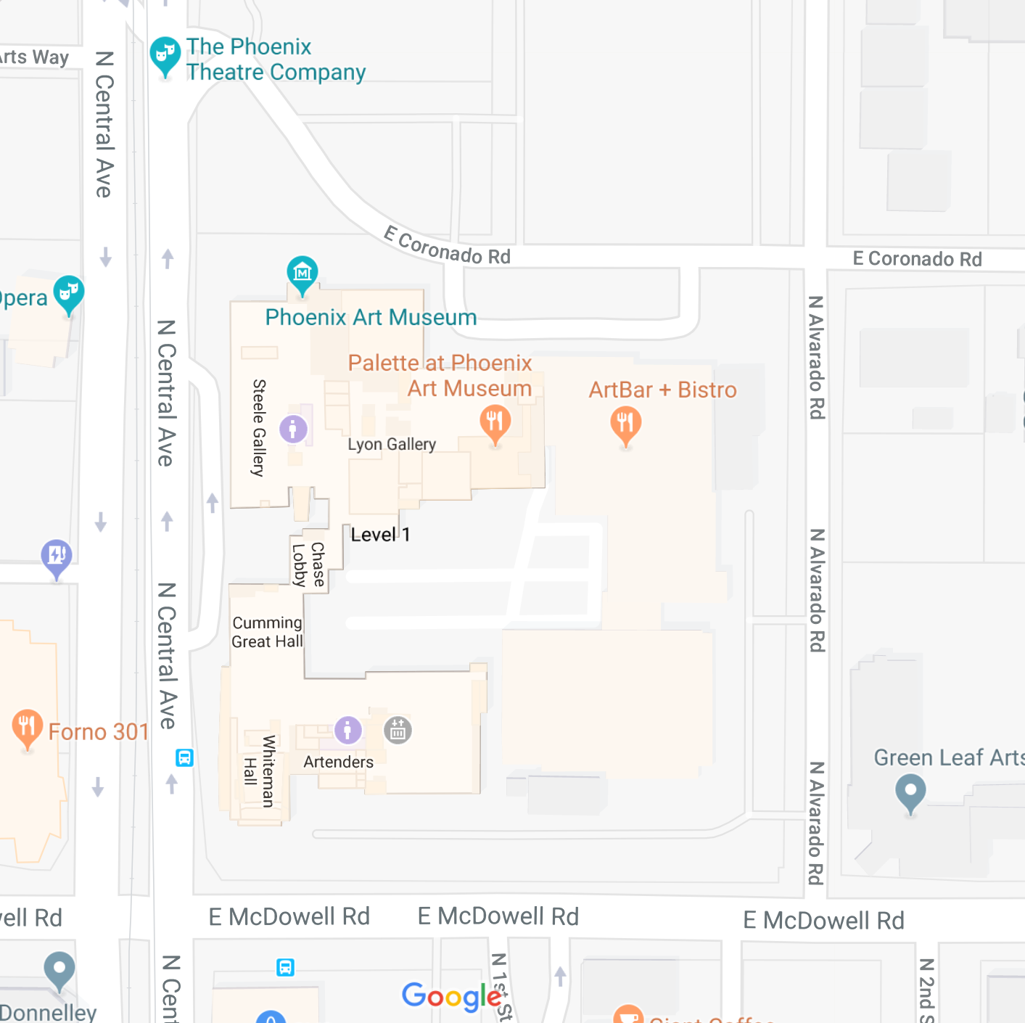
Camper Drop Off and Pick Up
Additional Parking
The Phoenix Theatre Company
1825 North Central, Phoenix, AZ 85004
(Central and McDowell, next door to the Phoenix Art Museum)
Enter off of McDowell and Alvarado. Free parking is available in the north and south lots. Camp Headquarters is located in Rehearsal Room A, which is located at the Southeast corner of McDowell and Alvarado. Look for the large Art Bar & Bistro sign facing Alvarado.

